## Ascend and Descend

Ascend by generating more lift than weight and vice-versa.

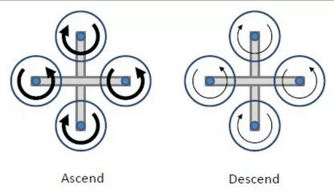

Figure 3.e: Ascend and descend (Bold arrow represents higher RPM)